Name: | ___________________________________________________ |  |  |  |  | Date: ___________
 | Subject - Year 8 Mathematics  Investigation 1, 2018  Topic – Perimeter & Area  In class component |  |  |  |  | 42  = %
Total Time: | 60 minutes
Equipment: | Scientific Calculator, Take home component
Date out: |  | Week ____ Date _____________ |  | Date Due: | Week ____ Date _____________
AIM: In this assessment, you will be investigating area and perimeter for simple and composite shapes.

1. | Perimeter of a rectangle [7 marks: 1, 1, 2, 3]
 | Miranda’s bedroom is 5m x 4m x 2.5m high, with a doorway 1m wide and 2 m high in one of the 4m sides.
a) | Sketch a floor plan of Miranda’s room
b) | Add the appropriate dimensions to the floor plan of Miranda's room.
c) | Calculate the perimeter of the room so that Miranda can fit cornice material where the ceiling and walls meet.
d) | Calculate the amount of skirting board needed if Miranda is to fit skirting board where the walls and floor join. (There is no skirting where the door is)

2. | Perimeter of a Square[4 marks: 2, 2]
 | Miranda decides to add a square mat.
a) | What is the length of the largest mat to fit the room?
b) | Miranda wishes to add an extra strip around the perimeter to protect the edge of the carpet. How much edging material does Miranda need?
3 | Tiled rectangles [ 6 marks: 2, 1, 1, 1, 1]
 | Miranda has a very small kitchen 2m x 3m x 2.5m high and wishes to tile the floor using 200mm square tiles.
a) | What is the area of each tile?
 | (i) in 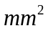
 | (ii) in 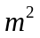
b) | How many tiles are needed along the long wall?
c) | How many tiles are needed along the short wall?
d) | How many tiles are needed altogether?
e) | What is the total tiled area?
4 | Area of triangular carpet [ 3 marks: 2, 1]
 | Miranda decided to try a triangular carpet in her 5m x 4m bedroom.
a) | What are the height and base of the maximum size of carpet that she could use? | Height ________ m  Base ________ m
b) | What is the area of this carpet?
5 | Area of rectangular carpet [ 3 marks: 2, 1]
 | Miranda decided to try a rectangular carpet in the bedroom.
a) | What are the maximum length and width of carpet that she should use? | Length _________ m  Width __________ m
b) | What is the area of this carpet?
6 | Area of a Square carpet [2 Marks]
 | Miranda wanted to try the square carpet used previously in the perimeter question (Question 2)
 | What is the area of the circular carpet?
7 | Area of right angle triangle [ 3 marks]
Miranda wants a shade sail as shown below

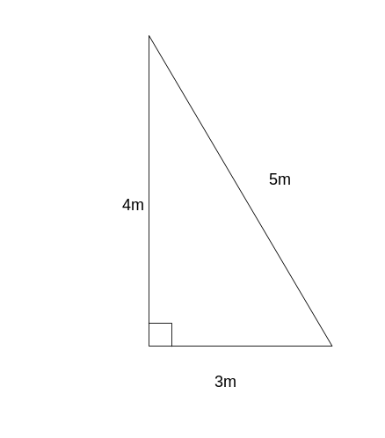

 | Calculate area of the material need to make the shade sail?
8. | Area of non-right triangle [3 marks]
Miranda decides to use a design like the one below.
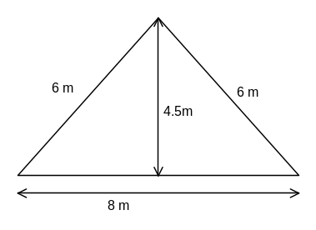
 | Calculate the area of material used.
9. | Area of rectangle with rectangle removed [6 marks: 2, 1, 1, 1, 1]
 | Miranda decides to turf the back yard which is 15m x 12m and includes a fish pond in the centre measuring 2.4m x 2m
a) | Draw a sketch plan of the yard
b) | Mark all dimensions you have been given on your plan.
c) | Calculate the area of the yard?
d) | Calculate the area of the pond?
e) | Calculate the area of turf needed?
10. | Rectangle with Trapezium removed [3 marks: 2,1]
Miranda decides to have a trapezoidal fish pond with a top, bottom and height of 2.4 m, 3.2m and 2m respectively instead.
(The back yard is still 15m x 12m. )

a) | Calculate the area of the pond
b) | Calculate the area of lawn left after the pond is dug out.

